COMP Cams® FSL™ Series Camshaft for GM L99 Engines

Memphis, TN – COMP Cams® is introducing the first performance aftermarket camshaft in almost 20 years to pass the stringent California Air Resources Board (CARB) Executive Order (E.O.) process for a domestic engine.

The CARB E.O.-pending camshaft offers drop-in convenience, with no valve spring change required, for Gen V (2010-15) Camaro SS GM L99 engines. Designed to work with factory Variable Valve Timing and require no computer reprogramming, the camshaft also features unique profiles on switching and non-switching cylinders for compatibility with Active Fuel Management systems. It provides the proven 30- to 50-HP improvement typical of smaller COMP Cams® camshafts in LS applications without the risk of non-compliance with emissions regulations.

The COMP Cams® FSL™ Series Camshaft for GM L99 Engines claimed the 2017 SEMA Best New Street Performance Product Award and is the first in a new series of 50-state legal camshafts from the absolute leader in valve train technology.
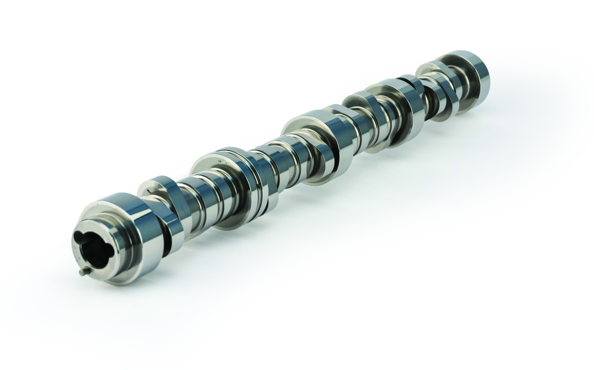
Quick Facts

Product: COMP Cams® FSL™ Series Camshaft for GM L99 Engines
Part Number: 689-199-13
Street Price: $464.59

Social Media Pitch: The COMP Cams® FSL™ Series Camshaft for GM L99 Engines increases performance while complying with emissions regulations

Features & Benefits:
CARB E.O. certification pending
Drop-in convenience on Gen V (2010-15) Camaro SS GM L99 engines; no valve spring change required
No computer reprogramming to work with factory VVT and AFM systems
Improves performance by 30 to 50 HP

About COMP Cams®

Founded in 1976 and based in Memphis, TN, COMP Cams® has become the automotive performance aftermarket’s “Absolute Leader in Valve Train Technology.” Our mission is to produce the highest-performing products possible, provide superior customer service and lead the industry in technological development. Additional information about COMP Cams® and its products can be found at www.compcams.com or by calling 1.800.999.0853. You can also visit us on Facebook (facebook.com/COMPWins), Twitter (twitter.com/COMPCams), Instagram (instagram.com/compcamsofficial) and YouTube (CPGNationTV.com).

Media Contact: Cindy Bullion, cbullion@compcams.com, 901.795.2400 ext. 1643.

